Database Keys

* Keys ensure we uniquely identify the tuple

**Candidate Keys**

A candidate key is one attribute or the smallest combination of attributes that can uniquely identify each row in a table

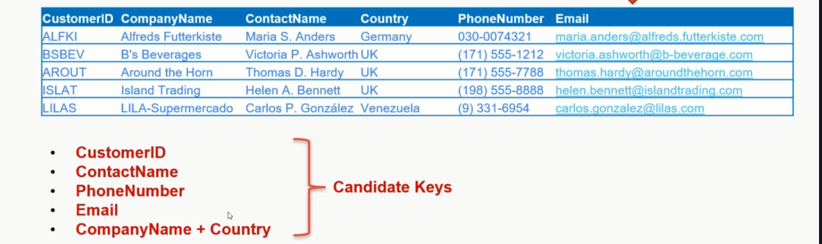

Primary Key

A primary key is the candidate key on which the primary key constraint will be defined and is the main reference key for the table

**Value should not change in future

So we cannot make ContactName, Phone Number, Email a primary key.

Also

CompanyName+Country is not selected for primary key as

***when we create primary key constraint , clustered index is also created by default , maintining a large index is complex.

Here we select , CustumerId

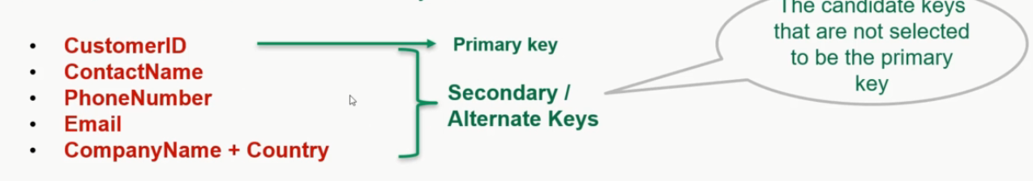

**Composite Key**

A composite key is a primary key that consists of at least two attribute that uniquely identify each row in a table and of which one more of the attribute that make up the composite key not simple key in their own right.

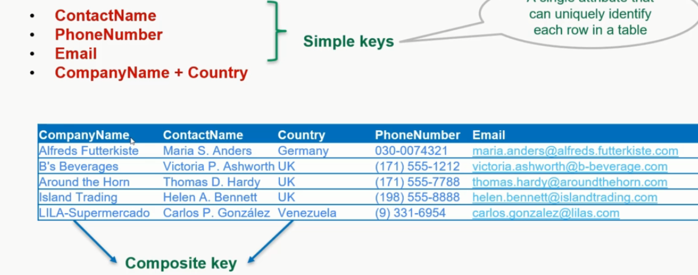

Surrogate Key

A Surrogate key is an artificial key that does not contain a fact about the object being modelled . its usually a system generated integer that will used the primary key to identify each row in table .

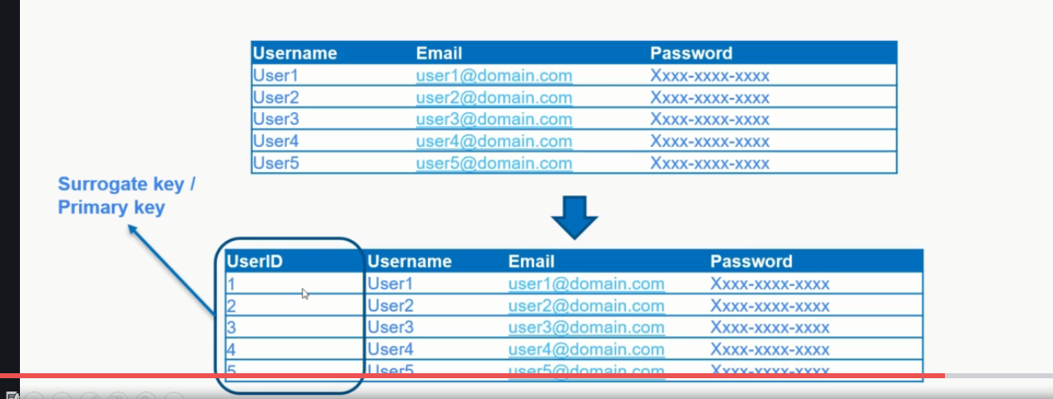

Enable identity property of column this will auto generate values

**Foreign Key**

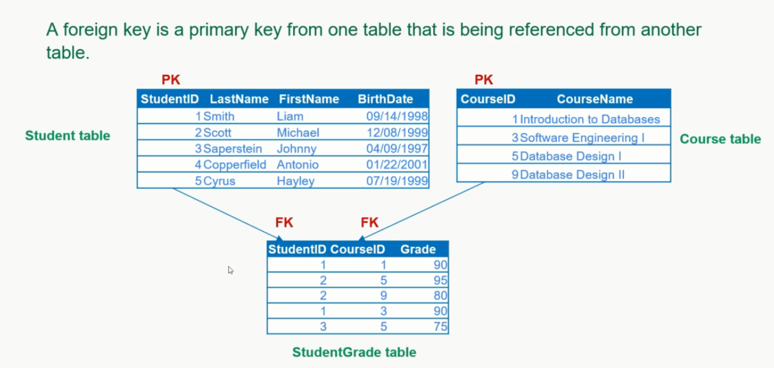

Compound Key

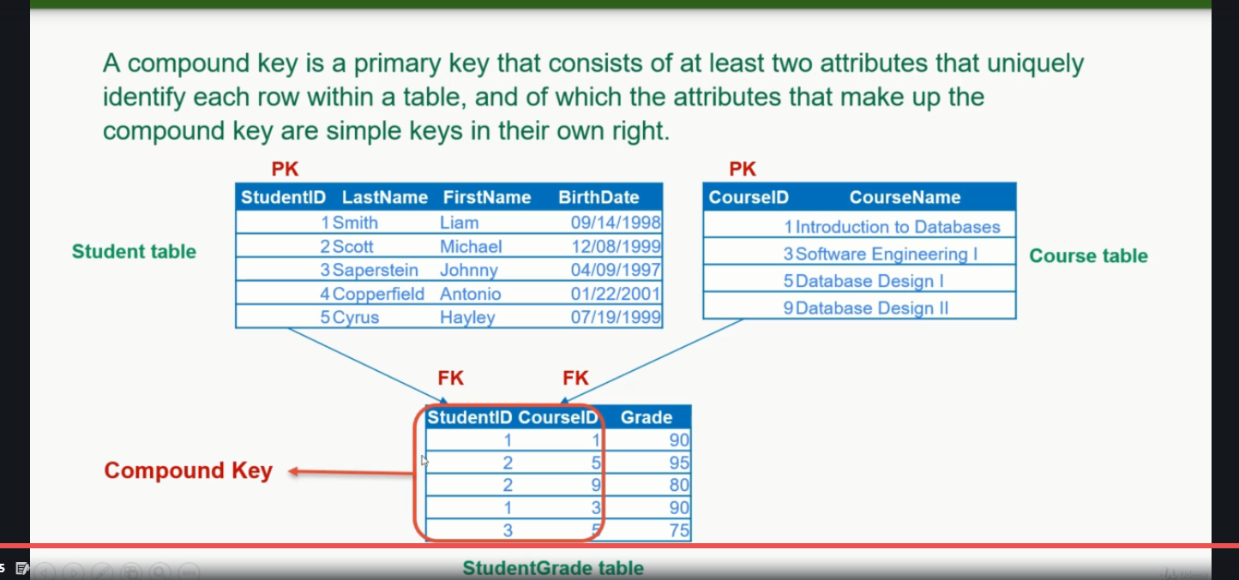

Every compound key is composite key but every composite key is not Compound key . to be compound key each key should uniquely identify the tuple.